
ONSITE® CAR SERVICE
QuickRide®
BOOK ALL YOUR TAXI , CAR SERVICE
AND LIMOUSINE RIDES HERE.

QuickRide® HIGHLIGHTS
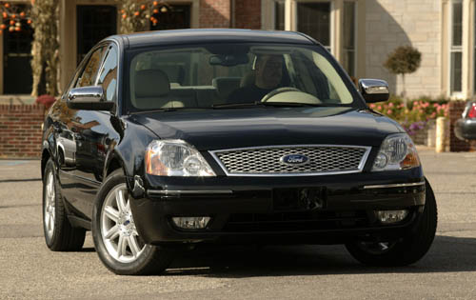
LOGAN AIRPORT FROM $29.75* (AS LOW AS $18.00/PERSON, IF SHARING) BASED ON PICKUP LOCATION.
LOCAL RUNS FROM $15.00* (FOR UP TO 3 GUESTS)
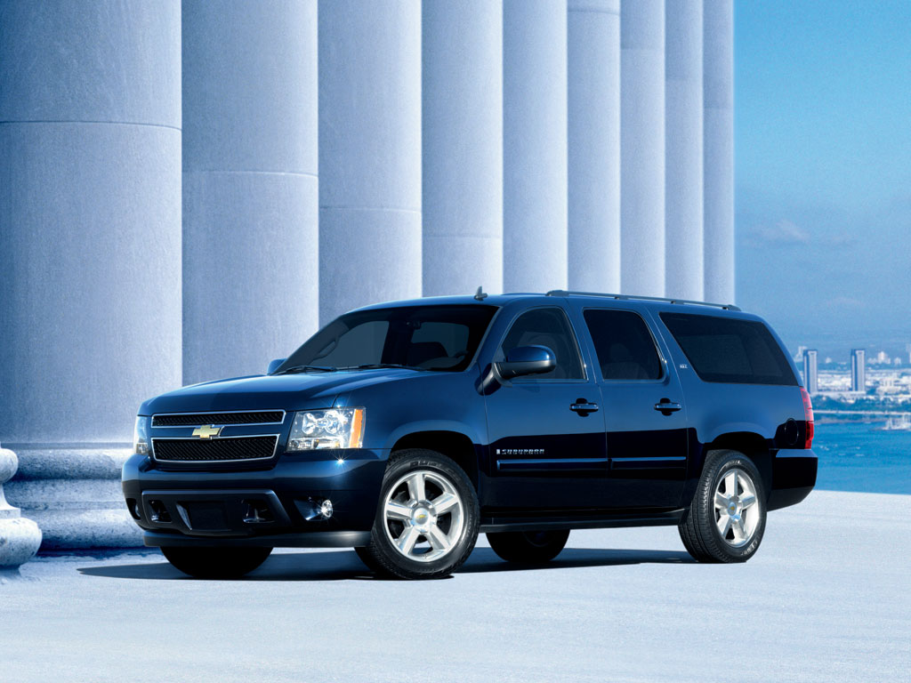
LIMO SERVICE AT NEAR TAXICAB PRICES.
AFFORDABLE ALTERNATIVE TO TAXI SERVICE.
SUITABLE FOR SHORT NON-MISSION-CRITICAL TRIPS AND WALK-OUT GUESTS.
NO ADVANCE RESERVATIONS.
FOR ADVANCE RESERVATIONS AND MISSION CRITICAL TRIPS ASK FOR FullRide® SERVICE.

PAY CASH, CREDIT CARD OR ROOM CHARGE**

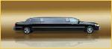
LIMITED AVAILABILITY & AT SELECT HOTELS.
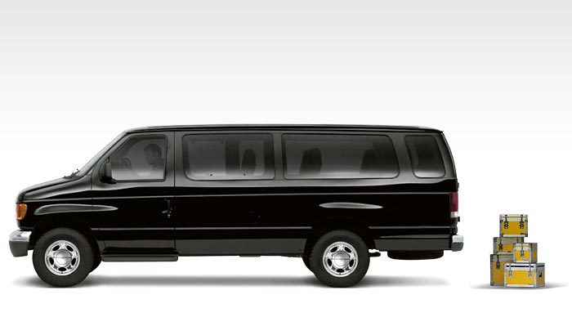
ZERO GRACE PERIOD. ANY WAITING TIME AND ADDITIONAL STOPS ARE EXTRA @ $1.00/MINUTE WAITED, $20.00 PER STOP FOR SEDANS, OTHER VEHICLES HIGHER.

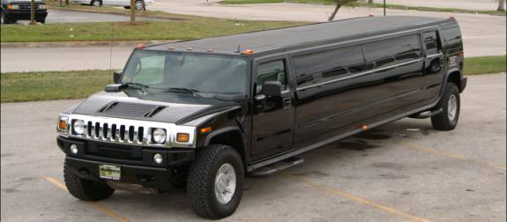
* PLUS ADMIN CHARGE (HIGHER OF $5.00 OR 10%)
* PLUS TOLLS (IF APPLICABLE, LOGAN IS $5.25)
** AT SELECT HOTELS.
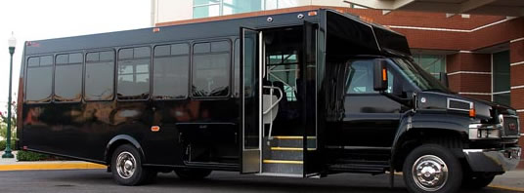
SEE CONCIERGE/GUEST SERVICES FOR HELP.
OR CALL 617-785-2945 TO BUY DIRECT.
E-MAIL: RESERVATIONS@RTILIMO.COM.
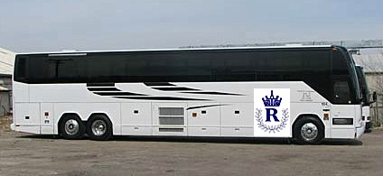 ONSITE® CAR SERVICE
POWERED BY ROYAL TRANSPORTATION INTERNATIONAL
© COPYRIGHT 2009. ROYAL TRANSPORTATION INTL. L.L.C. ALL RIGHT RESERVED. THE ,ONSITE®, QuickRide®, FullRide® SYMBOLS ARE REGISTERED TRADEMARKS OF ROYAL TRANSPORTATION INTL. L.L.C... ALL OTHER SYMBOLS AND LOGOS ARE REGISTERED TRADEMARKS OF THEIR RESPECTIVE OWNERS. (QR 20090101)

