
StadiumEXPRESS®

BOOK ALL YOUR CHAUFFEURED TRANSPORTATION TO THE GILLETTE STADIUM HERE. AVAILABLE EVERYDAY!

StadiumEXPRESS® HIGHLIGHTS

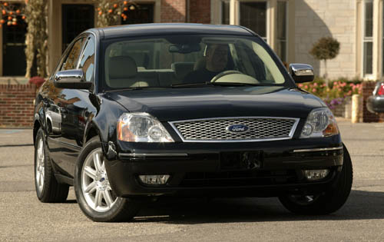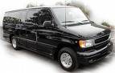
FROM $95.00 PER PERSON ROUNDTRIP TO GILLETTE STADIUM, FOXBORO (FROM BOSTON)
MINIMUM OF 4 PEOPLE REQUIRED.
DROPOFF AND PICKUP ONLY.
ITEMS CANNOT BE LEFT IN VEHICLES.
OTHERWISE ASK FOR FullRide® A/D SERVICE.
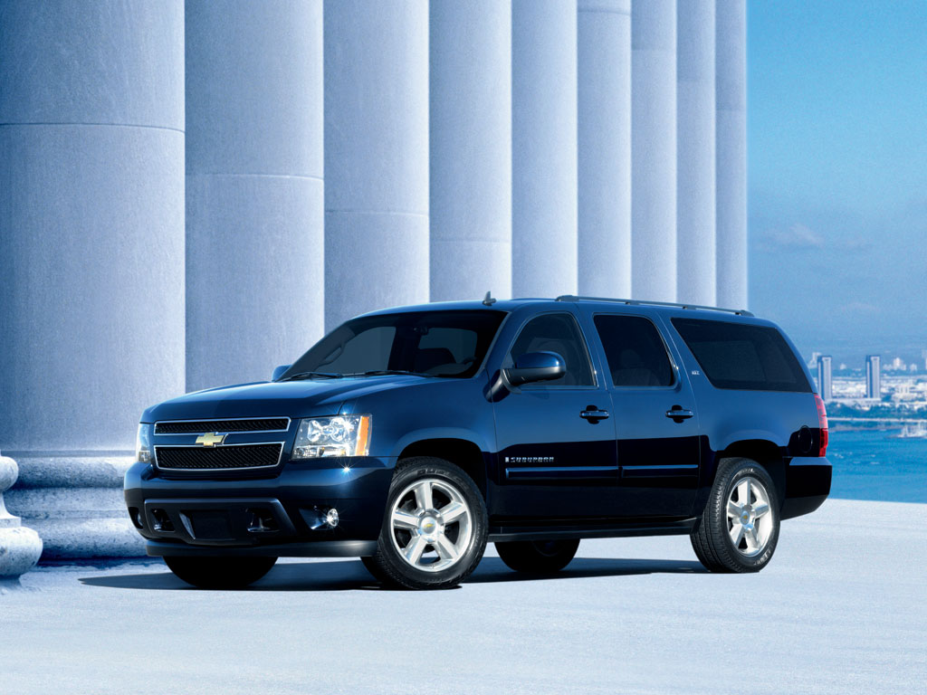
RETURN 1 HOUR AFTER GAME ENDS.
PREPAY CASH, CREDIT CARD OR ROOM CHARGE**

DEPART UP TO 3 HOURS BEFORE GAME STARTS.

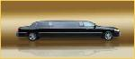
BOARD 15 MINUTES BEFORE DEPARTURE/RETURN.
TICKETS ARE NON-CANCELABLE /NON-REFUNDABLE. IT IS CUSTOMERS’ RESPONSIBILITY TO BOARD ON TIME.
24-HOUR ADVANCE BOOKING RECOMMENDED.

SEE CONCIERGE/GUEST SERVICES FOR HELP.
OR CALL 617-785-2945 TO BUY DIRECT.
E-MAIL: RESERVATIONS@RTILIMO.COM.
** AVAILABLE AT SELECT HOTELS
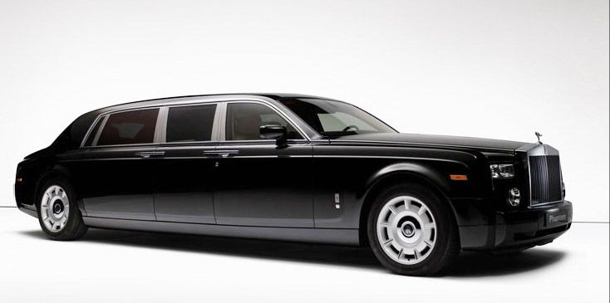
StadiumEXPRESS®
POWERED BY ROYAL TRANSPORTATION INTERNATIONAL
© COPYRIGHT 2009. ROYAL TRANSPORTATION INTL. L.L.C. ALL RIGHT RESERVED. THE AND THE StadiumEXPRESS® SYMBOLS ARE REGISTERED TRADEMARKS OF ROYAL TRANSPORTATION INTL. L.L.C... ALL OTHER SYMBOLS AND LOGOS ARE REGISTERED TRADEMARKS OF THEIR RESPECTIVE OWNERS. (SX 20090101)

